Assignment #3 – Cursors, Procedures & Functions

Due Date: Midnight of July 21 (Friday)

Purpose: The purpose of this assignment is to help you:
- Become familiar with Cursors, Exceptions, Procedures and Functions

Instructions: Be sure to read the following general instructions carefully:
This assignment should be completed individually by all the students. Submit your solution through the ecentennial. Your submission should include PL/SQL code and the screenshot of code execution result, the submission must be named according to the following rule: studentID(yourlastname)_Assignment#number.doc. e.g., 300123456(smith)_Assignment#3.doc

Questions [14 marks]

- [3 marks] Create a function to calculate a shopper’s total spending, excluding shipping and tax amount, with Brewbean’s site in a particular year. Exception handling is needed.
Use an anonymous block to call the function and output the result.
/* question 1 */

CREATE OR REPLACE FUNCTION totalSpending(shopperid bb_basket.idshopper%type)
RETURN bb_basket.subtotal%type IS
total bb_basket.subtotal%type;
BEGIN
SELECT SUM(subtotal)
INTO total
FROM bb_basket
WHERE idshopper = shopperid
GROUP BY idshopper;

RETURN total;
EXCEPTION
WHEN NO_DATA_FOUND THEN
RETURN 0;
END;
/

SELECT firstname,
lastname,
totalSpending(idshopper)
FROM bb_shopper;
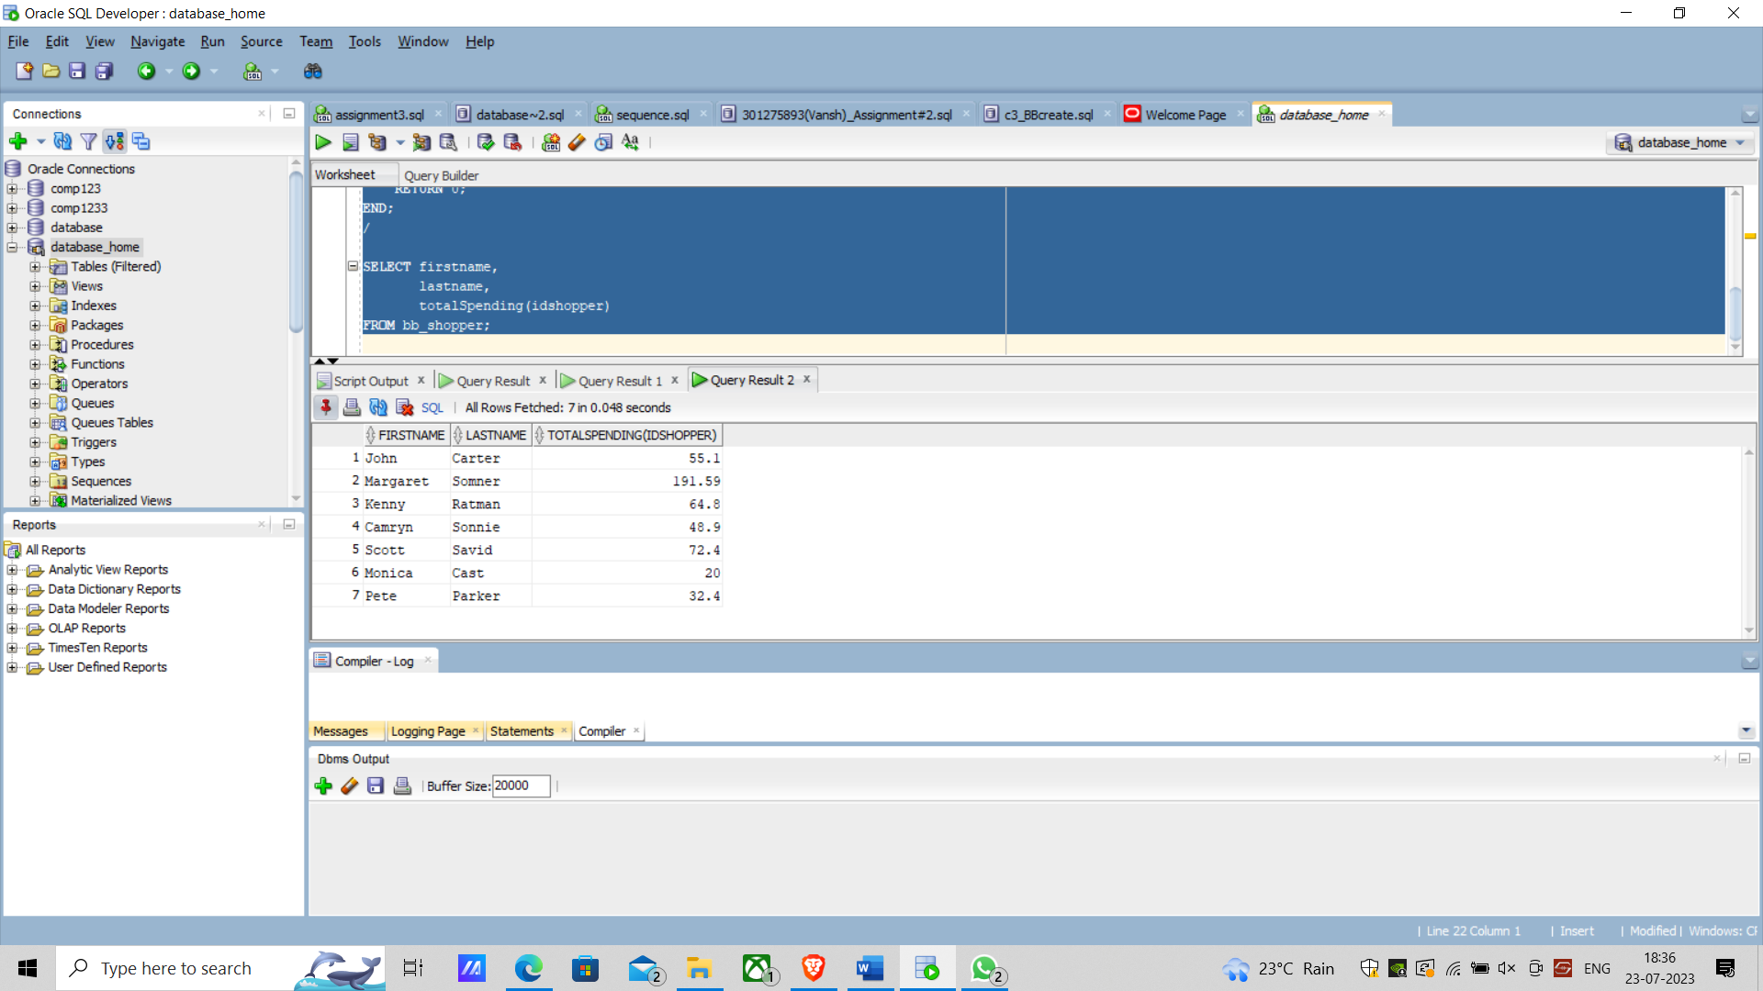
- [3 marks] Create a procedure to allow an employee in the shipping department to update an order status to add shipping information. The BB_BASKETSTATUS table lists events for each order so that a shopper can see the current status, date, and comments as each stage of the order process are finished.
Use an anonymous block to test your procedure.

/* question 2 */

create or replace procedure status_ship_sp
(p_id in bb_basketstatus.idbasket%type,
p_date in bb_basketstatus.dtstage%type,
p_shipper in bb_basketstatus.shipper%type,
p_track in bb_basketstatus.shippingnum%type)
is
begin
insert into bb_basketstatus
(idstatus, idbasket, idstage, dtstage, shipper, shippingnum)
values (bb_status_seq.nextval, p_id, 3, p_date, p_shipper, p_track);
commit;
end;
/
execute status_ship_sp(3, '20-FEB-07', 'UPS', 'zw2384yxk4957');
/
select idstatus, idbasket,idstage,
dtstage, shipper, shippingnum
from bb_basketstatus;

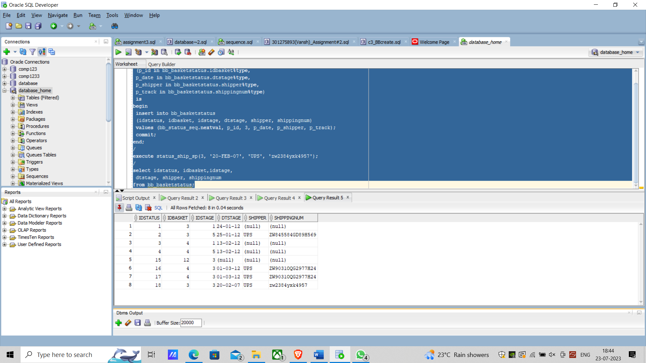

- [3 marks] Create a function to insert a new product into an existing order, include the product id, unit price, quantity. The output of the function is the message to notify the calling program whether the update succeeded or not.
Use an anonymous block to call the function and output the result.

/* question 3 */

create or replace function orderupdate(productid bb_basketitem.idproduct%type,
unitprice bb_basketitem.price%type,
quantities bb_basketitem.quantity%type,
basketid bb_basketitem.idbasket%type,
basketitemid bb_basketitem.idbasketitem%type)
return number
is
begin
insert into bb_basketitem (idproduct, price, quantity, idbasket, idbasketitem)
values(productid, unitprice, quantities, basketid, basketitemid);
dbms_output.put_line('Success');
return 1;
exception when OTHERS then dbms_output.put_line(' NO Success');
end orderupdate;
/
declare
var1 number;
begin
var1:=orderupdate(6,1,2,3,48);
end;
/
select * from bb_basketitem;

- [3 marks] Create a function to determine the total pledge amount for a project. Use the function in an SQL statement to list all projects, displaying project ID, project name, and project pledge total amount. Format the pledge total amount to show a dollar sign.
Add at least two rows in dd_pledge for the project “Covid-19 relief fund” which you created in assignment#2.
/* question 4 */
CREATE OR REPLACE FUNCTION total_calculator(projectid dd_pledge.idproj%type)
RETURN dd_pledge.pledgeamt%type IS
total dd_pledge.pledgeamt%type;
BEGIN
SELECT SUM(pledgeamt)
INTO total
FROM dd_pledge
WHERE idproj = projectid
GROUP BY idproj;

RETURN total;
EXCEPTION
WHEN NO_DATA_FOUND THEN
RETURN 0;
END;
/

SELECT TO_CHAR(total_calculator(d.idproj),'L9G99') AS TotalAmount,
d.idproj,
d.projname
FROM dd_project d
GROUP BY d.idproj, d.projname;
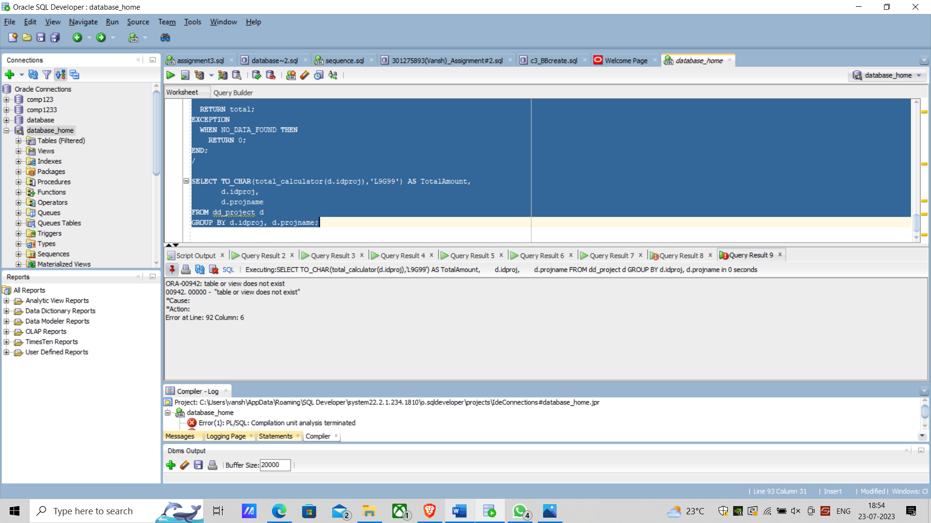

- [2 marks] Create a procedure to allow company employee to add new product to the database. This procedure needs only IN parameters.
Use an anonymous block to test your procedure.

/* question 5 */

create or replace procedure basket_add_sp
(p_id in bb_basketitem.idbasket%type,
p_prod in bb_basketitem.idproduct%type,
p_price in bb_basketitem.price%type,
p_qnty in bb_basketitem.quantity%type)
is

begin -- insert into table
insert into bb_basketitem (idbasketitem, idbasket,
idproduct, price, quantity)
values (bb_idbasketitem_seq.nextval, p_id, p_prod,
p_price, p_qnty);
commit;
end;
/
Column description heading 'description' format A50;
select idproduct, description from bb_product;
/

